**Report**

Course Name: Software Development

Course Code: CSE 400

**Supervised By**

Name: Md. Laisuzzaman

Designation: Lecturer

Department of CSE

Sylhet Engineering College

**Group Members**

Enamul Hasan(2019331503)

Md. Fuad Khan(2019331513)

Md. Bodrul Islam(2019331507)

**Title**

LipoBlog : A Multi-User Blogging Platform

**What is a Blogging Platform ?**

Blogging is an amazing way to improve your writing, explore areas of interest in depth, learn the basics of website management and SEO, and — perhaps most importantly, develop clarity of thinking.

A blogging platform is a software or service used to manage and publish content on the internet in the form of a blog. A blog—short for weblog—is a record of a user's entries online, usually in reverse chronological order.

A blogging platform allows the user to create, organise, and publish written and visual content online in a blog.

**What is LipoBlog?**

LipoBlog is a Blogging website which means broadcast-style communications systems that enable authors to publish articles, opinions or product reviews (known as posts), which can be delivered through stand-alone websites, email, feed syndications systems and social networks. Blogging platforms also enable direct reader participation with the host blogger or with other blog participants by enabling user comments. LipoBlog allows the user to create, organise, and publish written and visual content online in a blog.

**How LipoBlog Works**

LipoBlog allows the user to publish posts, display the date that the post was published, and assign a specific author assigned to the post. These software or web-based services also allow users to tag content with specific categories, making it easier to search for all posts on topic within the blog.

A user can create and manage his personal blog site in lipoblog and after publishing the posts any internet user can read his posts and see his blog site.

**Objectives**

**improves your writing —** Most people cannot write well. By committing to a blog and sticking with it for at least 6–8 months, your writing will improve. The practice of writing blog posts — and the added pressure of making them public — is the practice of an invaluable craft.

**Keeps you current** — No matter how passionate you think you are about a certain subject, there will be days (and even weeks) when you aren’t inspired to write. Here’s where the habit and consistency of blogging kicks in — it will force you to read more and keep current in your topic so you have ideas for additional posts.

**Teaches website management** — No matter what platform you use, be it Wix, Squarespace, Wordpress, etc., publishing blog posts will force you to learn the basics of back-end website management and SEO — perhaps even HTML and social media marketing as well.

**Build a portfolio** — At the end of the day, you own the content of your blog — no publication or platform can change their algorithm or delete your posts. This is particularly true in social media marketing — hard to be a Vine star today since its owners opted to close it down.

Blogs provide ways for you to not only express your thoughts and (potentially) build an audience, but also build a portfolio of original work at your pace and on your terms.

**Improves your analytical skills** — Writing blog posts requires you to clearly organise your thoughts, write persuasively and edit ruthlessly — these are skills that spill over beyond mere writing into other areas of thinking and analysis.

**Tools**

* Django framework.
* Python.
* HTML
* CSS
* BootStrap
* Javascript
* SQLite
* Git and github
* Visual Studio code

**Programming Languages & Database**

**Programming Language:** To build this blogging site we use the django framework. Django is a Free and open-source framework for building web apps with Python language. Django features:

* The admin site
* Object-relational mapper (ORM)
* Authentication
* Caching

That's why for back-end operations we use python code.For front-end we used HTML, CSS, BootStrap.

**Database:** SQLite Supports relational database . It is an open source database that stores data to a text file on a device. Android comes in with built in SQLite database implementation. SQLite is a local database. It stores data locally so In order to access this database, you don't need to establish any kind of connections for it like JDBC,ODBC etc.

**Output**

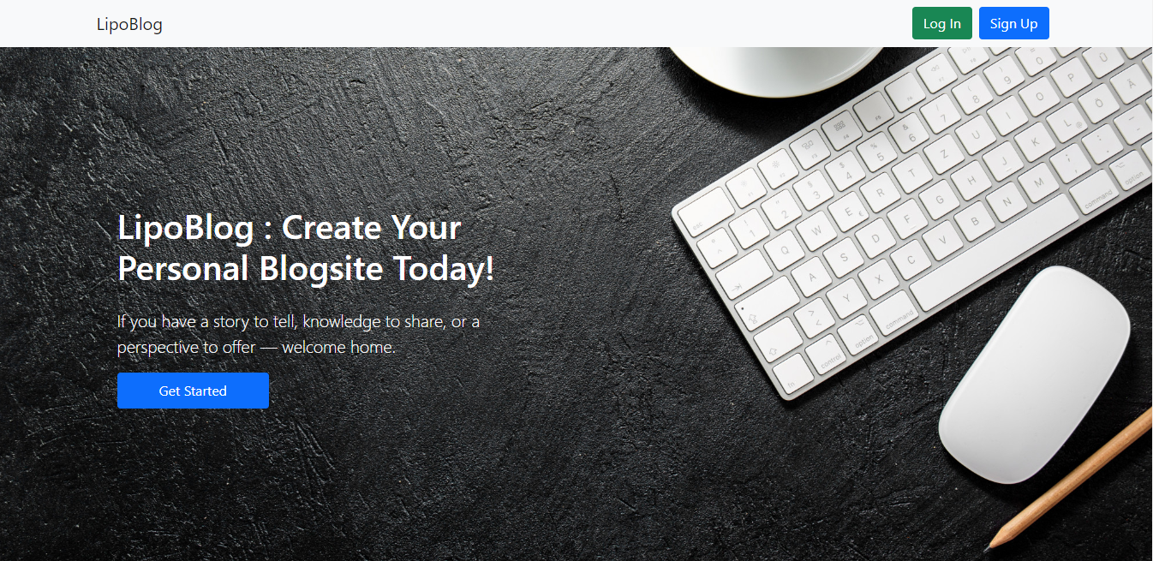

**Registration layout:**

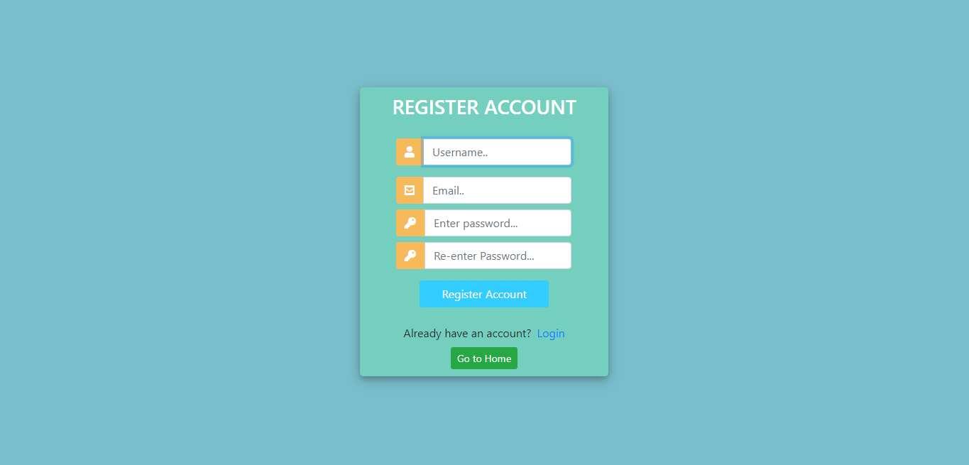

**Login layout:**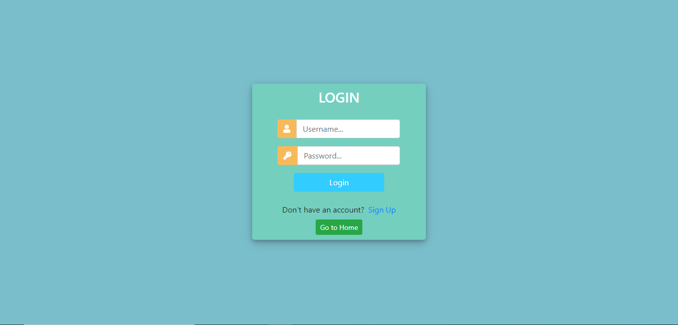

**Home Page:**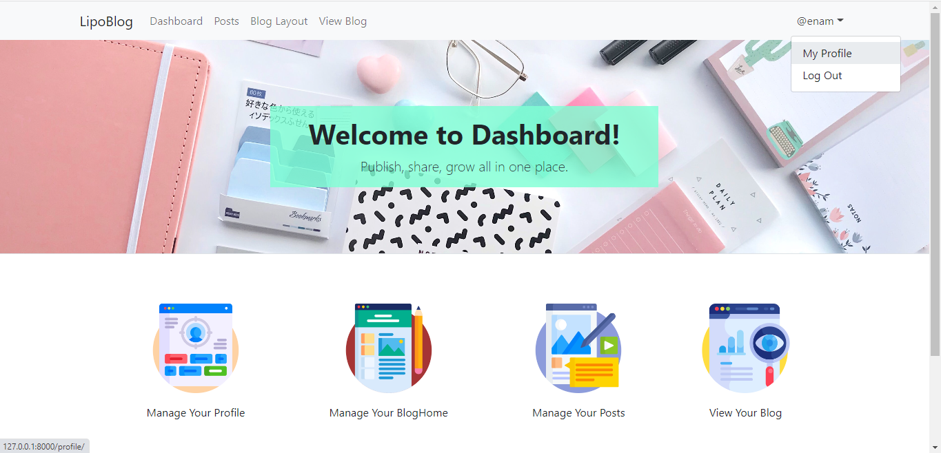

**Profile layout:**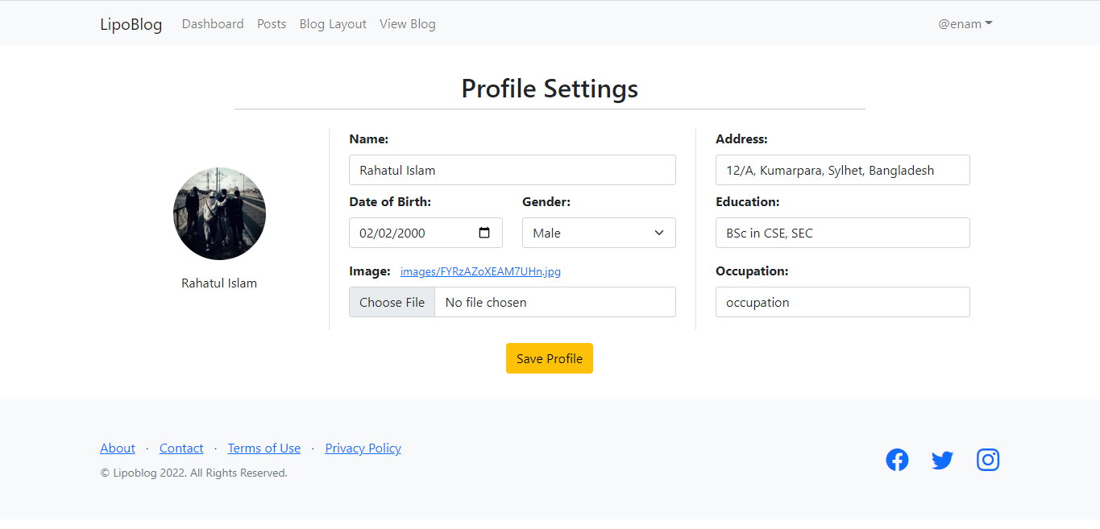

**Post, Edit post and Create post layouts:**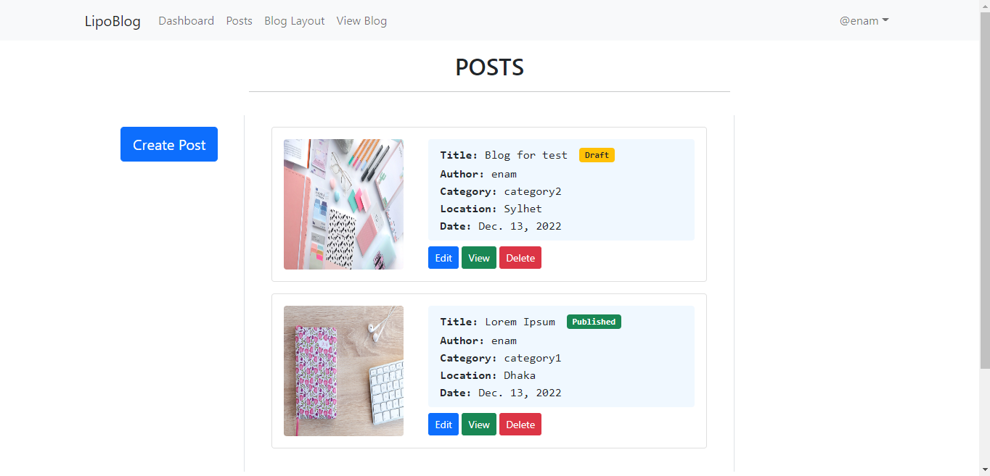

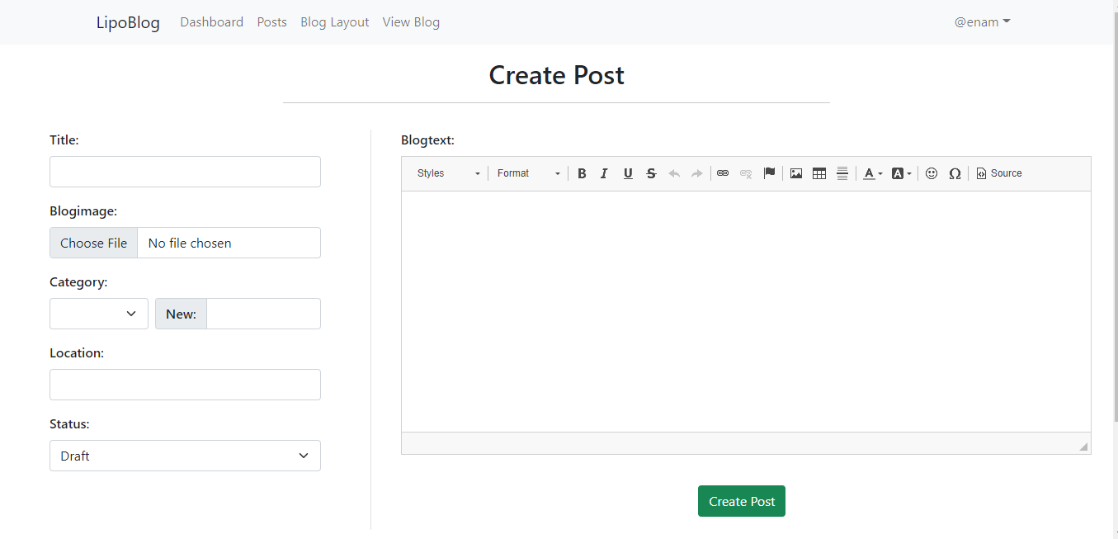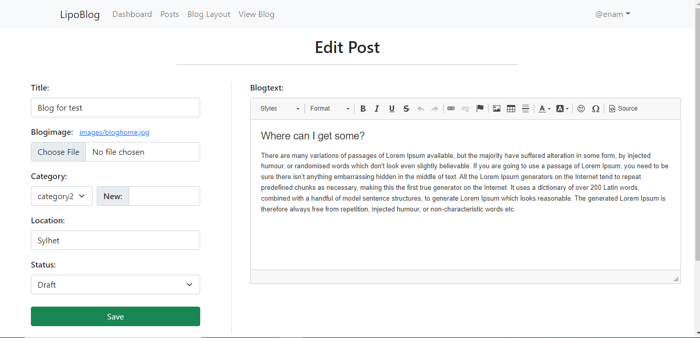

**blog site layout:**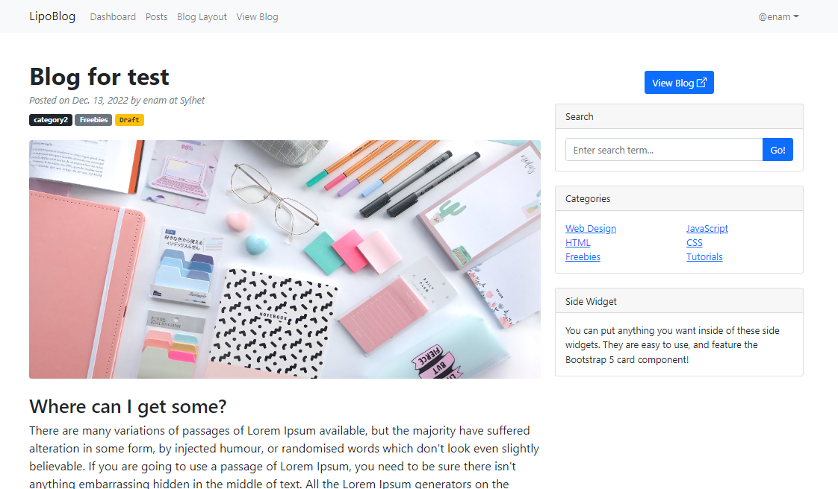

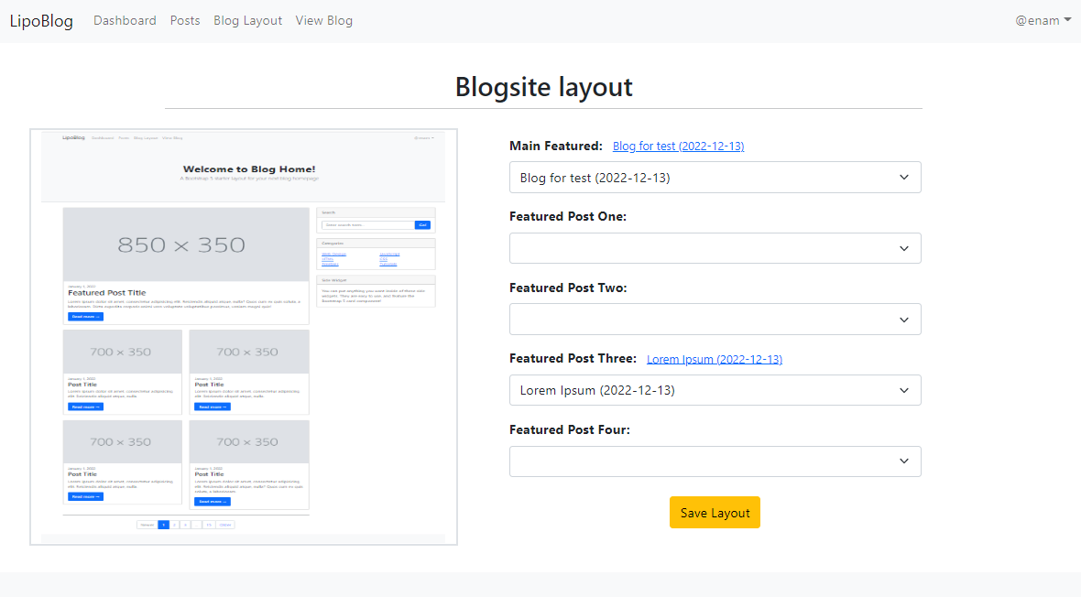



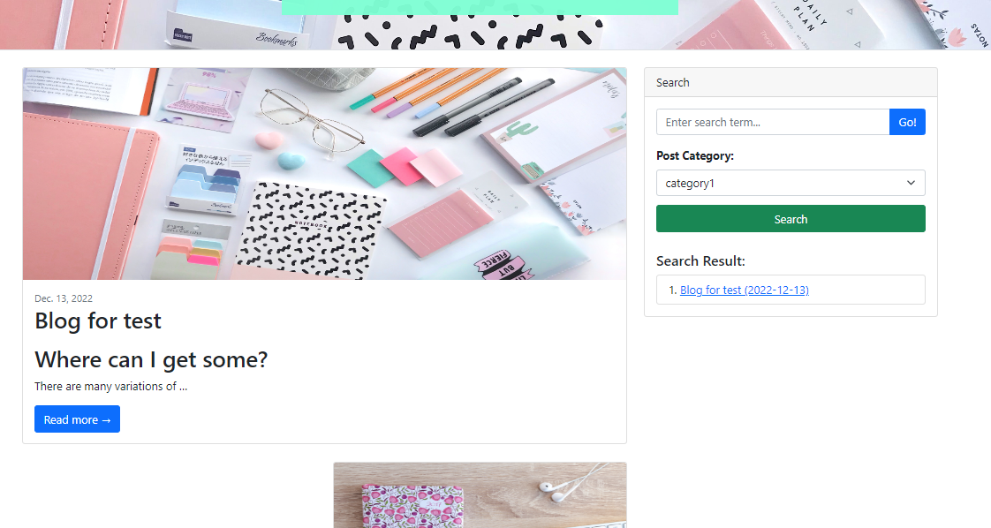

**Admin panel layout:**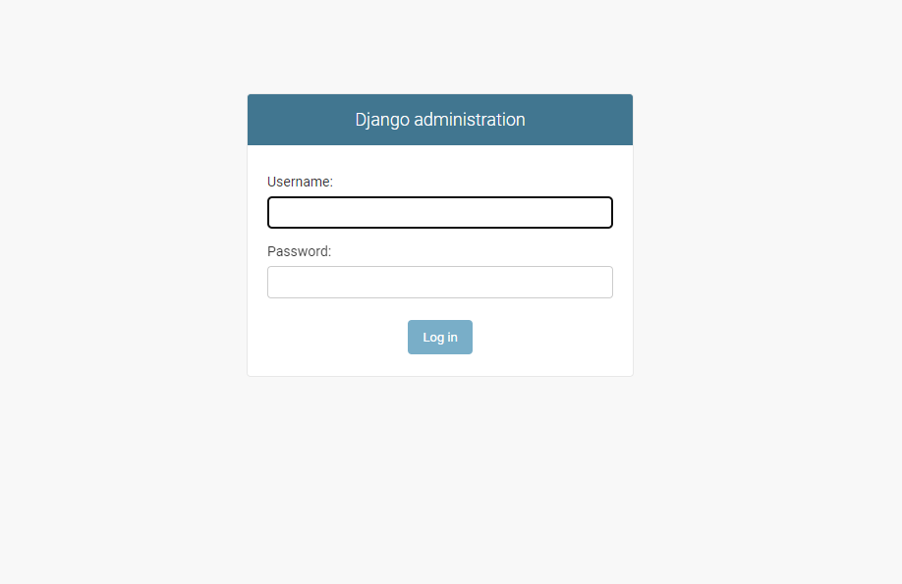

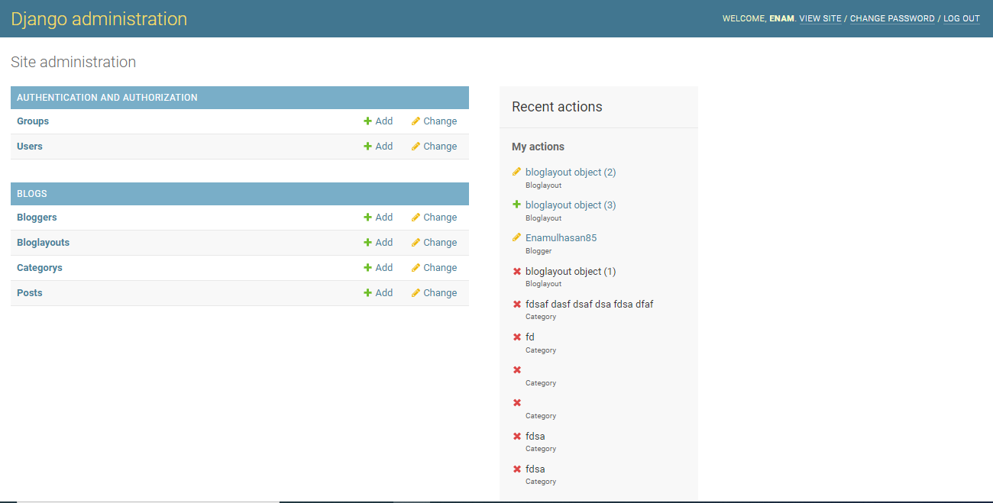

**Future Plan**

* Making the LipoBlog fully dynamic.
* Adding a comment option of any viewer of a post.
* React options after reading an article.
* Linking lipo portfolio with other social media platforms like Facebook. Twitter, Instagram etc.
* Voting options for a post.
* Easy Navigation.
* E-mail subscription.
* Displaying post in reverse order.
* Creating a blog post archive system.
* Comment spam protection.
* Creating contact method.

**Conclusion**

We design LipoBlog for the bloggers who want to express the new idea of her or his with the people. It’s a multi user blogging system where we can see various kinds of writers and bloggers. Making this blogging platform we learned front-end developing tools like html, css, bootstrap and back-end developing tools like python, django framework. We also learned about blogging platforms, how to manage it and so on. We hope this site will create a new era in Bangladesh blogging system.

Blogs provide ways for you to not only express your thoughts and (potentially) build an audience, but also build a portfolio of original work at your pace and on your terms.

So yes - I think you should start a blog. Play with it, commit to it. In a year, you’ll be amazed at what you’ve built.